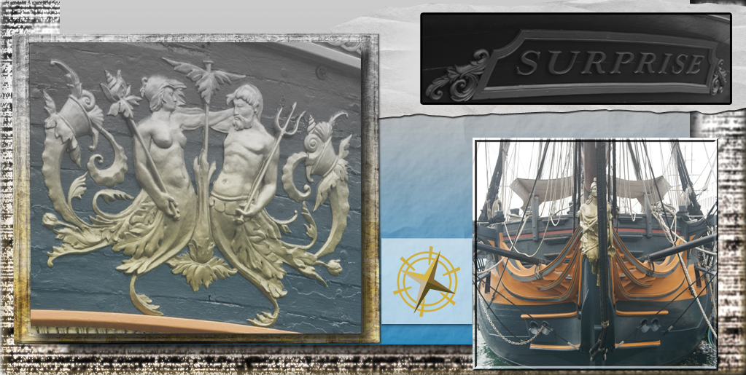

August 2013

Sun | Mon | Tue | Wed | Thu | Fri | Sat
 |  |  |  | 1 | 2 | 3
 |  |  |  | Sylum Advent Sign Ups - Open
4 | 5 | 6 | 7 | 8 | 9 | 10
11 | 12 | 13 | 14 | 15 | 16 | 17
 |  |  |  | Sylum Advent Sign Ups - Closed
18 | 19 | 20 | 21 | 22 | 23 | 24
25 | 26 | 27 | 28 | 29 | 30 | 31

